St Gregory the Great Catholic Primary School
ANNUAL
REPORTTO THE SCHOOL
COMMUNITY
REGISTERED SCHOOL NUMBER: 1678
2019
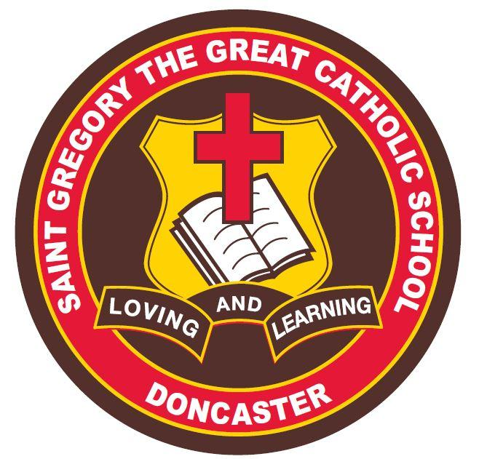
Contents
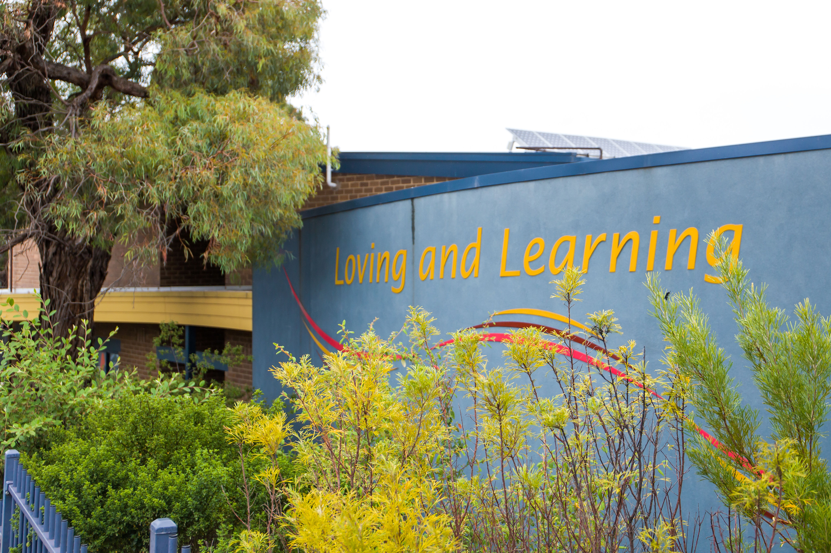

Contact Details 2
Minimum Standards Attestation 2
Our School Vision 3
School Overview 4
Principal’s Report 5
Parish Priest’s Report 6
School Education Board Report 7
Education in Faith 8
Learning & Teaching 9
Student Wellbeing 10
Child Safe Standards 12
Leadership & Management 13
School Community 14
Future Directions 15
School Performance Data Summary 16

Contact Details
ADDRESS | 396 Manningham Rd,  Doncaster. VIC. 3168
PRINCIPAL | Miss Michelle. A. Verna
PARISH PRIEST | Rev. Monsignor Anthony. J. Ireland. STD, EV, PP.
SCHOOL BOARD CHAIR | Mrs Deirdre Diamante
TELEPHONE | (03) 9848 4483
EMAIL | principal@sgdoncaster.catholic.edu.au
WEBSITE | www.sgdoncaster.catholic.edu.au
E NUMBER | E1268

Minimum Standards Attestation
I, Michelle Verna, attest that St Gregory the Great Catholic School is compliant with:
- All of the requirements for the minimum standards and other requirements for the registration of schools as specified in the Education and Training Reform Act 2006 (Vic) and the Education and Training Reform Regulations 2017 (Vic), except where the school has been granted an exemption from any of these requirements by the VRQA
- Australian Government accountability requirements related to the 2019 school year under the Australian Education Act 2013 (Cth) and the Australian Education Regulations 2013 (Cth)
- The Child Safe Standards prescribed in Ministerial Order No.870 – Child Safe Standards, Managing Risk of Child Abuse in School.
26th of June, 2020.
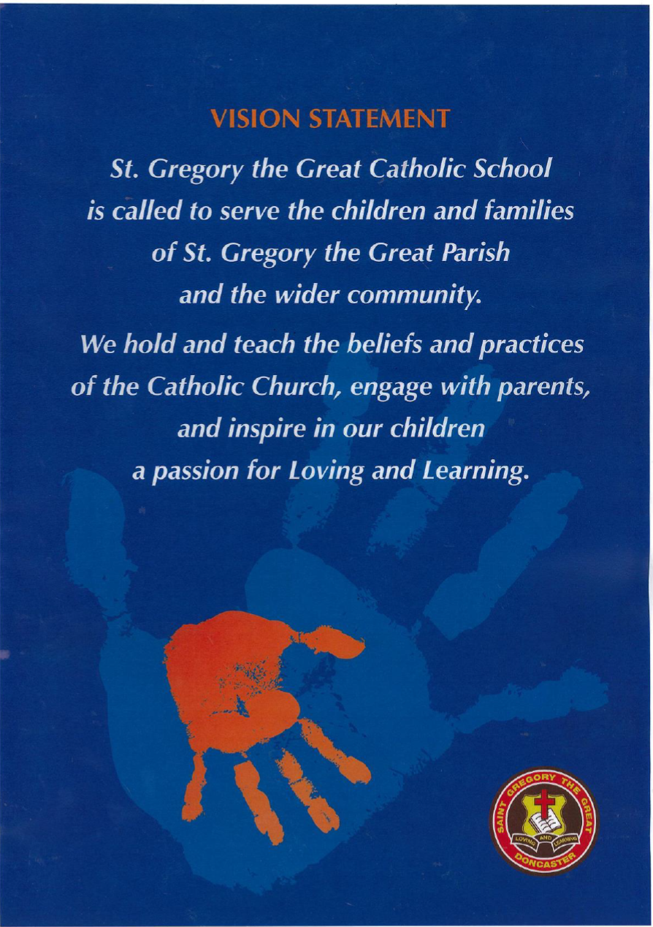
Our School Vision

School Overview
HISTORY
St Gregory the Great Catholic Primary School is situated on the corner of Manningham and Williamsons Roads, Doncaster. The school commenced in 1968 as one room at Ss Peter and Paul’s Primary School, East Doncaster. During 1969, three portable classrooms were purchased from East Doncaster and moved to the present site on Williamsons Road. These three portables, along with other portable classrooms were bricked together to form the main building. Children moved into this block at the commencement of term three, 1969. St Gregory’s received formal registration from the Registered Schools Board in February, 1970 under the direction of the first Principal, Teresa Bushell, Fr John Mullally was the first Parish Priest. The present Parish Priest, Monsignor Anthony Ireland, has been at Doncaster since September 2009. Miss Michelle Verna, current Principal, commenced at St Gregory The Great Catholic Primary School in January, 2018.

PARISH
St Gregory the Great Catholic Primary School is called to serve the children and families of St Gregory’s Parish. We strongly believe that the school is a vital component of the Parish in the faith of its children from Prep to Year 6. We cherish our supportive community spirit. We celebrate our faith with contemporary liturgies, give practical witness to Gospel values and explore current social issues. Throughout the school year many opportunities are provided for school families and parishioners to be actively involved in educational, emotional and fundraising activities. The major aim of our Parish Primary School community is the Christian development of the children within the context of the Catholic tradition. From Year 3 onwards, children have the opportunity to be trained as altar servers and commit to service at Parish Masses. Years 3, 4, 5 and 6 children attend the 9am Parish Mass each week.

SCHOOL
On Census day in February, 2019, there were 394 children enrolled at St Gregory the Great Catholic Primary School in 17 classes organised as follows:

3x Prep classes
3x Year 1 classes
2x Year 2 classes
2 x Year 3 classes
2x Year 4 classes
5x Year 5/6 classes
St Gregory the Great Catholic Primary School is in the high socio-economic grouping of schools and in 2019 employed 43 staff members. At all times the staff of St Gregory the Great Catholic Primary School is dedicated to the education and wellbeing of our children. We are a high achieving school and go to great lengths to maintain this level of achievement, as identified in the School Improvement Plan.

Principal’s Report
Dear Parents and Friends,
It is with great pleasure and dedication that I present this report as principal at St Gregory the Great Catholic Primary School. We are proud of our achievements this year as we continually aspire to improve.
At St Gregory the Great Catholic Primary School we strive to communicate openly with parents. We believe that it is vital for our families to be active members of our parish and school community. This report has been uploaded to the school website and parents can collect a copy from the school office or be sent on request.
St Gregory the Great Catholic Primary School is a vital component of the Parish in the faith of its children from Prep to Year 6. We encourage all parents to be active members of St Gregory’s Parish and to share in the richness of belonging and contributing to this community. A strong partnership between School and Parish is important and a valuable experience for our children and their families.
At St Gregory the Great Catholic Primary School we acknowledge the fact that parents are primary educators of their children and we are delighted to be able to assist in the academic, social, emotional and spiritual growth of our children in order for them to contribute to our world. We believe that we must nurture an ongoing partnership between home, school and parish to ensure the development of the whole child.
Through actions, words and the example of our own lives, the staff of St Gregory the Great Catholic Primary School endeavour to provide education in faith for your child/children. It is our aim that your child/children come to know the person of Jesus Christ and be encouraged to live out the Gospel values in their daily lives.
The year began with the school celebrating its 50th Jubilee, the commissioning of teachers during a Parish Mass in early February and address the School/Parish community. The preparation of the School and Parish Sacramental program commenced on Wednesday the 27th of March, when our Year 3 students received the Sacrament of Reconciliation. Our Sacramental program continued on Sunday the 8th September 15th September with our Year 3 students from the School receiving the Sacrament of First Eucharist. The celebration of the Sacrament of Confirmation was on Sunday 21st July. It was a delight to see the Year 6 students from the School and other children from our Parish, come together for this celebration.
Throughout the year, it was such a joy to see our many learning and teaching projects come to fruition. Our strong focus on STEM (Science, Technology, Mathematics and Science), saw the partnership develop with or Junior students and Marcellin College VCAL students in building insect hotels and presentations from students at the Catholic Education Melbourne STEM MAD Showcase event, where our school won the Catholic Ethos award
Our LOTE program saw the integration of Italian and Mandarin through many events such as our Chinese New Year celebration and Multicultural day. The many sporting events and camps were enjoyed by our students. Sporting events involved whole school sports days, regional cross country, swimming events and inter-school sports. Our sequential Camp program from Prep to Year 6 saw, Teddy Bear picnics, day out, pizza and movie, Camps involved a retreat at Amberley in Templestowe for our Year 3 students, Sovereign Hill for Year 4 students, Canberra camp for our Year 5 students and Alexandra Adventure Resort for our Year 6 students.
At St Gregory the Great Catholic Primary School, we promote many Social Justice projects. Our Mini Vinnies team was commissioned early in the year and these students participated in many events to support Caritas Australia, St Vincent De Paul and Kids View Social Justice Conference. In 2019 we held two mini fetes, one run by our Year 3/4 students and one run by our Year 5/6 students. Money raised was sent to support our sister school “Sayaw’ in the Philippines. Our Year 6 students and their parents also participated in a sleepout in the school hall in June. Money raised was to support the work for the St Vincent De Paul Society’s work for the homeless.
Please join me in thanking and congratulating our students, parents and staff for their great efforts in 2019!
Michelle Verna
Principal

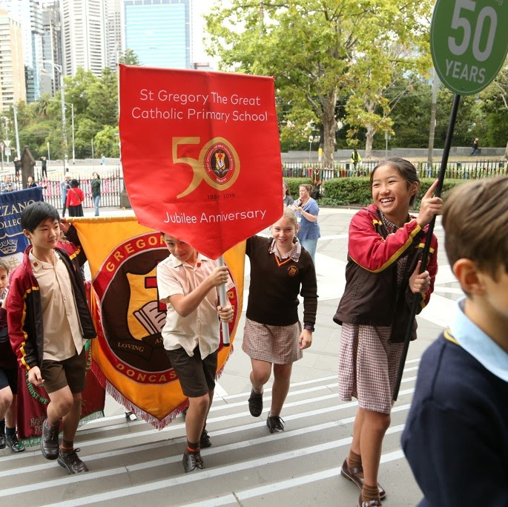

Parish Education Board Report
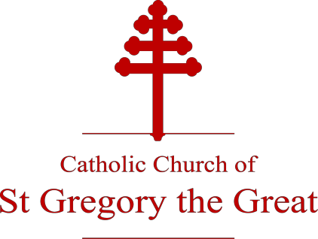

PARISH EDUCATION BOARD MEMBERS 2019
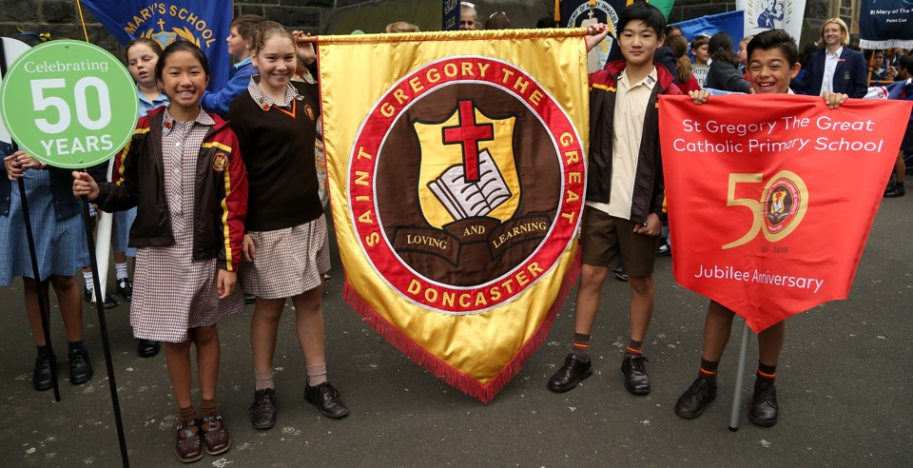
Parish Priest
Monsignor Tony Ireland
Principal
Michelle Verna

Deputy Principal
Josie Italiano

Parents Association
Rachel McMahon

Chairperson
Deirdre Diamante

Parishioner and Parent Representatives
David Chow Karen Chay Peter Molinari

ABOUT THE PARISH EDUCATION BOARD
The Education Board comprises the Parish Priest, Principal, parishioners, parents and staff and acts as a forum through which the Parish Priest and Principal can receive measured and informed advice on issues affecting the parish and school.
Parish Education Board

CHAIRPERSON’S END OF YEAR REPORT - 2019

Dear Monsignor Ireland, Michelle, Parents, Parishioners, Staff and Students,
On behalf of the members of the Parish Education Board, I am pleased to present the 2019 End of Year Report, covering the activities of the St Gregory’s Parish Education Board for 2019.

Parish Education Board Membership
There has been no change to the membership of the PEB during 2019.

Child Safety Standards
Compliance with the Child Safety standards has continued to be a strong focus of both the Parish Pastoral Council and the Parish Education Board. At St Gregory the Great Primary School we support the safety and dignity of all children, in particular those most vulnerable. However, we see child safety not simply as being compliant with external regulations; child safety is central to our Mission. Our mission and vision cannot be fulfilled without the development of a child safety culture. The Board has an ongoing role in supporting the school in building this culture as well as a formal role in ensuring compliance with the school’s Child Safe Code of Conduct. Further, the Board has a role in ensuring compliance with the child safety requirements of Catholic Education Melbourne and the Victorian Government, including the School’s implementation of the Government’s Resilience, Rights and Respectful Relationships’ (RRRR) program.
The PEB also supports the School’s cyber safety program which in 2019 included parent, student and teacher presentations/information sessions. The information sessions were both insightful and impactful and the Board encourages all school parents to attend future similar sessions.
Child Safety will continue to be a standing agenda item for the PEB in 2020.

Policy and Program Review
2020 will begin a policy review cycle for the School. In accordance with the PEB’s role to review and approve School policies, the School and PEB have begun preparing for this policy review. During the second half of 2019 the PEB has reviewed and supported the following school policies:
- Reporting Policy
- Learning Policy
- Teaching Policy, and
- Assessment Policy.

Importantly, during the year the PEB also supported the School in adopting the new “Parent / Guardian Code of Conduct”. This Code of Conduct establishes protocols for respectful relationships between all parents/guardians, teachers and the Principal. The conduct of all members of our school community will continue to be in focus during 2020.

2019 Sacramental Program
In 2019 the Parish celebrated a very successful Sacramental program. 4 masses were held in celebration of the First Eucharist: 2 masses for St Gregory the Great school students and 2 for children within our parish. 70 Grade 6 students were confirmed from the school community and from the wider parish community.
The PEB would like to acknowledge and thank Sister Carmel Krohn in preparing a number of children for their sacraments including 15 children prepared for Reconciliation, 16 for their First Eucharist and 2 for Baptism.

Considerations of the Board
Further considerations of the PEB in 2019 have included:
  - Closer cooperation between the parish and school
  - School Marketing
  - Learning and Teaching
  - Education in Faith
  - Naplan Results
  - School Leadership and Management
  - School Community, and
  - School Environmental Management Plan

These Board considerations will form the broad agenda for the PEB in 2020.

Leadership
The PEB would like to thank Michelle Verna for the significant leadership and contributions she has made to the school community. Through Michelle’s leadership, the school continues to build on its strong foundations that include community, learning and teaching and education in faith.
I would also like to thank Monsignor Tony Ireland, Michelle Verna and each of the members of the Board for their support and fellowship over the past year, and for their unceasing enthusiasm for the Board.

Deirdre Diamante
Chair, Parish Education Board
November 2019
Education in Faith

Goals & Intended Outcomes
School Improvement Goal

To strengthen our Catholic identity in the context of a contemporary world.

2019 Annual Action Plan Goals
- To develop and engage the professional dialogue of the staff when exploring the re-contextualisation of the Catholic faith and tradition.
- To build and strengthen the connection between school and parish
- Explore and embed the Renewed Religious Education Curriculum Framework in the context of
- Horizons of Hope (Catholic Education Melbourne).
- Continuation of RE Collective with St Francis Xavier Box Hill and Our Lady of Good Counsel
- Deepdene.

Intended Outcomes
- Religious Education lessons will be more engaging, thereby allowing students to make more explicit connections between faith and life.
- That the behaviours that reflect faith-based values will improve for staff and students.

Achievements
In order to achieve the goals and intended outcomes of St Gregory the Great Catholic primary School in the area of Education in Faith, the following strategies and ongoing practices were undertaken during the 2019 calendar year:
- The School Vision and Mission Statements have been central to the life and work of the school to continue to build a community in which the traditions and beliefs of the Catholic Faith permeate all areas of the curriculum
- The Religious Education Program at St Gregory the Great Catholic School sits within the context of the Education Framework for the Archdiocese of Melbourne, Horizons of Hope
- The Learning Progression at St Gregory the Great in Religious Education has followed the Religious Education Curriculum which comprises three strands of learning and five content areas:
- Knowledge and Understanding
- Reasoning and Responding
- Personal and Communal Engagement
- Scripture and Jesus
- Church and Community
- God, Religion and Life
- Prayer, Liturgy and Sacrament
- Morality and Justice
- The Catholic Education Melbourne Religious Education curriculum has been used by staff to inform planning and designing of the curriculum to provide authentic, relevant and rich learning experiences for the diverse learning needs and backgrounds of the students
- The Principal, Religious Education Leader and Director of Learning and Teaching continued to be a part of the Religious Education Collective along with staff from St Francis Xavier Box Hill and Our Lady of Good Counsel Deepdene. The focus of the collective was Assessment and Reporting in Religious Education
- Professional Learning led by the Principal, Religious Education Leader and Director of Learning and Teaching was provided for the staff in the area of developing effective strategies in designing assessment tasks based on the Religious Education Curriculum standards and achievements
- Moderation of student’s assessment tasks was undertaken as part of the collective agreement by staff at Professional Learning Team meetings to ascertain evidence of student learning in light of the Religious Education achievement standards
- As part of professional learning for staff, one of the two day staff conferences was dedicated to Education in Faith. The facilitator was Maria Forde and the focus of the workshop was ‘Talking About My Generation’
- Effective teaching pedagogy and resources were used to deliver a rigorous Religious Education Curriculum to provide opportunities for students to make links with the contemporary world and their faith development. This included the use of Scripture, Thinking Routines, Information Technology and drama
- Across the school levels, the Inquiry planner continued to include the Religious Education curriculum
- In planning, links have been created using the Principles of Catholic Social Teaching - each unit of work has featured an underlying principle to be developed and explored throughout the unit
- Formation evenings were offered to all parents from Prep to Year 6, covering the following topics and areas: ‘Who is Jesus’, My Relationship with God, My Family and Others’ and for each of the Sacraments. Presentations were facilitated by Monsignor Anthony Ireland, the Parish Priest, Staff, Maria Forde and Luke Bulley
- Commitment Masses for the candidates for First Reconciliation and Eucharist as well as Confirmation were celebrated at Parish Masses
- The Year 3 and 4 students took part in a Retreat at Amberley House as part of the Sacramental Program for Eucharist. Sr Carmel Krohn facilitated a session for the students with a focus on The Last Supper and the link between God’s love and the Eucharist
- The Year 3 students played a significant role in the Parish Holy Thursday Mass representing the disciples through their involvement in the ‘Washing of the Feet ritual
- The Year 6 students attended a Retreat Day at Holy Cross Centre in preparation for the celebration of Confirmation and to continue their own individual faith journey. This was led by Luke Bulley, a Passionist Brother
- The First Eucharist Masses were celebrated as part of the Parish Sunday Mass as a way to continue the children’s initiation into the wider church community. There were two Masses this year and the groups included catechists from the Parish Sacramental Program
- The Confirmation Mass was celebrated in St Gregory the Great Parish church by Monsignor Anthony Ireland for students from the school as well as Catechists
- St Gregory the Great hosted the 2019 Kids View Social Justice conference organised by the Bahay Tuluyan Philippines Australia group and the Year 5/6 students along with students from four other schools participated in the conference. The conference activities were designed around the 2019 theme - “Building a just world and my role as a global citizen” and was an opportunity for the children to extend their understanding and involvement in global Social Justice issues. This workshop day was followed with classroom activities led by the teachers and sharing the learning with the rest of the school through classroom visits
- Our Catholic faith continued to be celebrated as a community through assemblies, liturgies and Masses as determined by the Liturgical Calendar. These celebrations included Holy Week, The Resurrection, St Gregory the Great’s Feast Day, praying The Rosary and Migrant and Refugee Week
- Prayer continued to form an integral part of each day as the children and staff engaged in practices such as meditation and reflective opportunities to enable the deepening of their relationship with God
- The Year 3 to 6 students attended Parish Masses weekly with the parishioners. Students at these Masses led the readings and were the Altar Servers. Teachers prepared students for gospel readings, and students reflected on Monsignor Anthony Ireland’s take-home message as a follow up activity in class
- Class Masses for all levels of the school were held as part of Sunday Parish Masses to strengthen links between Parish and School. The students and their families had an active role in the Mass as readers, praying the Prayers of the Faithful and bringing forward the gifts for the offertory
- The School Choir lead the music at selected Masses each term, as well as part of Masses for the Sacraments of Eucharist and Confirmation
- Altar Serving was promoted through the school as an important Parish Ministry. This opportunity was for Year 4 – and once the Year 3s had received their First Eucharist, training was offered for those students who were interested in becoming an Altar Server
- Seven students from 2018 participated in The Guild of St Stephen Annual Admission Mass for Altar Servers
- The Catholic Identity of the school was highlighted with religious icons displayed in classrooms and around the school and in practices of prayer and worship
- The relationship with our Friendship School in the Philippines was strengthened through a visit from the KADASIG staff to our school. A KADASIG Leader and students who had recently attended an immersion trip to the Philippines visited the school and shared their experience with the whole school at an assembly
- Further opportunities were provided for students to focus on putting their Catholic faith in action by promoting support for our friendship school in the Philippines with the Middle and Senior school Mini Fetes. Money raised was donated to Sayaw Elementary to support school programs.
- The Mini Vinnies group for children from Year 5/ 6 met fortnightly with teachers to pray for others and to explore ways to be of service to others
- The Mini Vinnies led the community in hosting the Winter Sleepout and the Vinnies Christmas Tree appeal to raise funds and awareness of the needs of those in our community
- The feast of St Joachim and St Anne was celebrated with a whole school Mass and grandparents were invited. This was followed by school tours and morning tea for grandparents
- As part of strengthening and aligning links between Parish and School, the Parish Pastoral Plan was shared at the Parish Education Board Meeting. The staff were informed of the goals directly linked to the school and worked towards actions related to the school particularly
- Student’s work was on display in St Gregory the Great’s church, to share with Parishioners the rich learning in Religious Education and other curriculum areas in the school

Value Added
At St Gregory the Great Catholic Primary School, we continue to develop and strengthen our Catholic Identity through a rich and dynamic Religious Education program. Our Vision continues to provide the impetus to live out the Vision of the school whereby it is a priority to engage with parents and inspire in our children an appreciation for Loving and Learning.
There is a strong commitment from the staff who strive to implement current contemporary learning and teaching practices to ensure that the Religious Education Curriculum is relevant to the lives of the students and their families.
The Horizons of Hope Framework has been significant in guiding the implementation of the Religious education program with a focus on the core principles being ‘deep learning’, ‘animated learners’ and ‘powerful teaching’.
Professional Learning led by CEM RE Consultants provided the opportunity for all staff to further their understanding of Breaking Open the Religious Education Standards. This became a resource when planning Religious Education activities whilst at the same time enabling staff to focus on connecting effective teaching with relevant assessment tasks.
Opportunities were provided for students to put their faith in action through the school’s connection with our Friendship school in the Philippines by holding mini fetes run by the middle and senior

Learning & Teaching

Goals & Intended Outcomes
School Improvement Goal
To build a collaborative and engaging learning environment that focuses on rigour, challenge and high expectations.

Intended Outcomes
- That consistent practices and strategies for personalising student learning will lead to improved student outcomes (learning growth) in literacy and numeracy.
- That students will be more engaged and motivated learners.

2019 Annual Action Plan Goals
- To develop staff capacity in the use of data, particularly in Mathematics and in planning differentiated teaching strategies.
- To develop staff pedagogical content knowledge of Mathematics.
- Professional learning in a learning collaborative with at least 20 schools in the Eastern region. Lyn Sharratt (renowned and highly respected educationalist from Canada) will lead the professional learning days in 2019.
- Our focus will be in the area of improving student outcomes in Mathematics.

Achievements
During the year 2019, the following achievements and ongoing practices ensured the continued positive outcomes at St Gregory’s School in the area of Learning and Teaching:

- The staff continued to participate in professional development in a variety of areas such as the Learning Collaborative, Grammar in Context, Behaviour Management, capabilities through S.T.E.M. and growth coaching. Professional learning teams (PLT) allowed the opportunity for staff to collaborate in a collegial environment and engage in professional conversations. These conversations were initiated by professional reading on a variety of educational topics, student growth, moderation of work samples, planning effective and engaging activities and supporting and developing skills in a variety of areas

- The staff continued to provide excellent learning opportunities for all students by using data to inform teaching and learning and providing small focused group instruction that allowed for the differentiated approach to individual learning needs. The assessment used in 2019 was PAT M and PAT R, Essential Assessment, Running Records, Benchmark Assessment System (BAS), ARCOTS, NAPLAN, SINE and other formative and summative assessments. The data gathered from this testing has allowed the teachers to differentiate learning and cater to students needs with a more informed approach. The Specialist areas that were taught during 2019 were Physical Education, Visual Arts, Performing Arts, Mandarin and Italian languages

- New reporting format for 2019 reports using a tick box system that uses intended outcomes in all areas. The reports were developed with parent and teacher feedback determining the basis of the report structure. Positive feedback was received from many parents in regard to the new reporting
- The Learning Collaborative (TLC) led by Lyn Sharratt, was adopted by the whole school staff. The area of focus for the whole school is improving student growth in Mathematics. The 14 parameters of learning were unpacked and discussed and the staff revisited the importance of using learning intentions and success criteria to enhance student learning and allow for effective feedback. Case Management Meetings were introduced and this allowed teachers to use data to discuss student learning and design short term goals and activities that would improve student learning. The use of ‘Bump it Up’ walls was discussed, as well as Learning Walks and talks across the school. These initiatives will continue and develop in 2020

- New take home books and literacy resources were purchased for all levels. The Junior level also used the programs Sunshine Online and Wings Online to enhance their reading program. The Literacy Intervention Resource has been processed and the resource is being entered into filing cabinets. The Mathletics and Read Theory program continued to be used in Middle school and a new mathematics program called MangaHigh was introduced at the Senior level

- Book Week was a huge success with students dressing up and showcasing their favourite book characters. Leigh Hobbs, the author and illustrator of the ‘Old Tom’ book series, spoke to the students about creating characters and taught them how to draw a character in the Leigh Hobbs style. The students participated in literacy activities that related to reading and their favourite books and they were given the opportunity to read and vote for the shortlisted books chosen for the CBCA annual book awards

- The Kitchen/Garden program continued throughout all levels of the school and gave the students the opportunity to learn about the garden, plant seedlings and grow produce. This produce was then used to create culinary delights that would be shared amongst all of the students

- The Capabilities through STEM project in the junior school saw the design and implementation of enhancing the ‘Belonging Garden’ by encouraging indigenous insects and birds into the garden by making ‘insect hotels’, bird feeding boxes and birdbaths. These projects were completed in partnership with Marcellin College (VCAL students) and the projects have been placed in the ‘Belonging garden’

- The S.T.E.M. Mad Challenge was once again a huge success as St Gregory the Great school entered two teams into the competition run by Catholic Education Melbourne (CEM). The two teams focused on enhancing our ‘Common Home’. The first related to the Capabilities through STEM project which focused on the environment within the ‘Belonging Garden’ by encouraging indigenous wildlife. The second entry was a whole school sustainability initiative that was called ‘Be enthusiastic about less plastic’. This showcased ways in which students can reuse plastic and found ways to reduce the use of plastic, such as reusable lunch bags. Our Enhancing the Belonging Garden team was awarded a special prize for linking STEM and Religious Education throughout the project

- New Chromebooks were ordered for the school to enhance the use of technology in Year 3 and 4 classrooms. Laptop computers and iPads continue to be used in all classrooms allowing all students access to technological learning. The ‘Scratch’ program using coding, Lego Robotics, Makey Makey and Chromebooks in the senior school continued to enhance the technology and design curriculum. A group of year 5 girls were invited to participate in the Robogals program which took place at Melbourne University. This allowed them the opportunity to code and participate in a challenge with students from other schools across Melbourne. A fun experience that not only stretched their technical skills but their personal capabilities as well

- All classes across the school attended numerous excursions and incursions such as Healesville and LegoLand to enhance learning in the area of inquiry and capabilities. The Year 6 students attended the Halogen Leadership Conference to learn from significant leaders in the community. The camp policy extended during 2019 with the introduction of camp activities from Prep to Year 6. The year 5 and 6 students continued to go to Canberra and Alexandra Resort, the Year 4 students stayed at Sovereign Hill for two nights, the Year 3’s stayed overnight at Amberley House, the Year 2’s went on a whole day excursion, dinner and movie and the Year 1’s and preps participated in fun activities at school with an extended stay

- The achievements of 2019 have shown greater engagement in student learning and an increase in academic achievement. This was evident in the 2019 NAPLAN scores

NAPLAN DATA 2019

The NAPLAN results for 2019 were excellent in both Year 3 and Year 5. St. Gregory the Great students were above the state mean in all subjects, in both Year 3 and 5. The top cohort of students and the lower cohort of students were all above the state cohorts.
In comparison to 2017 and 2018, the NAPLAN scores of 2019 were higher than in the two previous years. This was evident in both the year 3 and year 5 scores in the subjects of reading, writing, numeracy, spelling, punctuation and grammar.
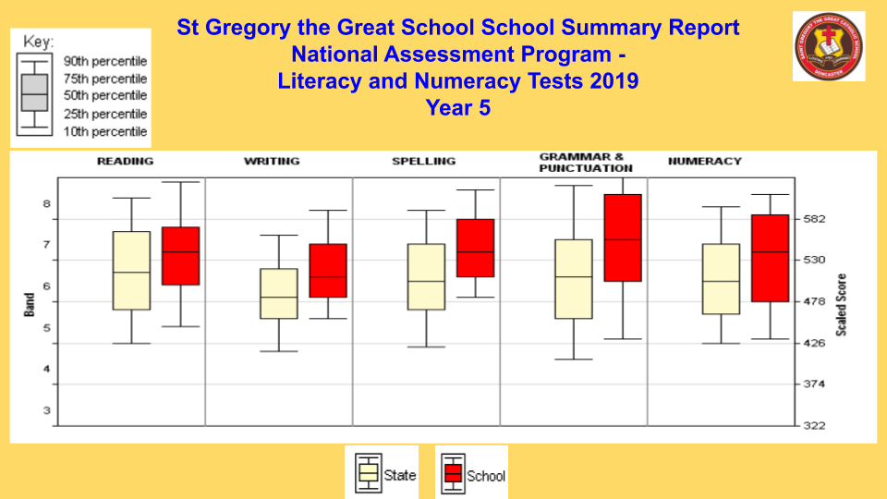
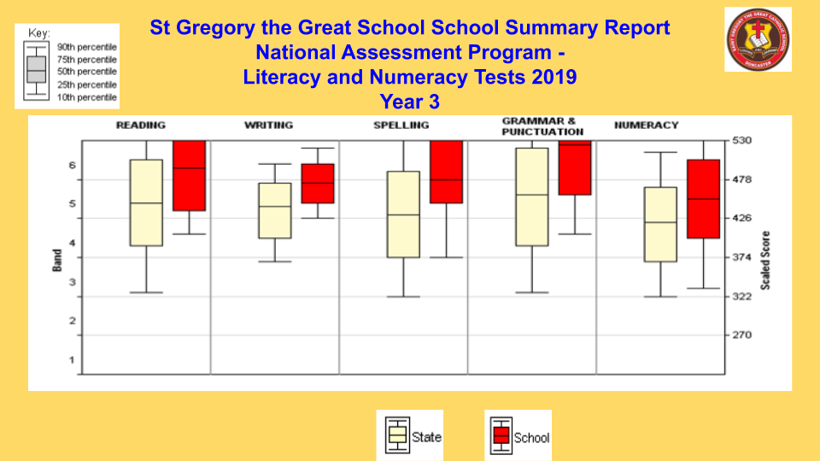

Programs and strategies that have had an impact on student learning:

- Using the data to inform teaching practice and differentiate learning
- Discussing and examining growth data at Professional Learning Team meetings
- Conducting ‘Case Management Meetings’ to discuss teaching pedagogy to enhance learning for selected students in Numeracy
- Selecting professional reading and professional development about current and effective teaching practice
- Selecting programs and resources to enrich the learning in literacy and numeracy for 2020.
Student Wellbeing
Goals & Intended Outcomes
School Improvement Goal
To develop students as self-managing and self- regulating learners who increasingly take responsibility for their holistic development and that of others

Intended Outcomes
- That students will be more confident in their learning.
- That student behaviour will improve.

2019 Annual Action Plan Goals
- To build and develop staff through professional learning opportunities in student wellbeing and Social Emotional Learning (SEL) pedagogy in the context of Horizons of Hope and the Victorian Curriculum capabilities.
- Continue to comply with Child Safe Standards and empower students in this area.
- Professional learning in (SEL) pedagogy in the context of Horizons of Hope and the Victorian Curriculum capabilities.

Achievements
In order to achieve the goals and intended outcomes of St Gregory the Great Catholic primary School in the area of Student Wellbeing, the following strategies and ongoing practices were undertaken during the 2019 calendar year:
- The Child Safe Standards and Reportable Conduct continued to be a major focus ensuring the implementation and management of the 7 Child Safe Standards and their continuous development and compliance with the Ministerial Order 870 Scheme
- Staff members completed the Mandatory Reporting eLearning module
- The Student Wellbeing Leader attended Student with Disabilities Application Guidelines and NCCD information briefing days followed by completing NCCD survey collection online for CEM NCCD moderation PD - NCCD Team working on submission
- The Student Wellbeing Leader and a staff member attended a NCCD twilight session at St Charles Borromeo to moderate strategies for data collection
- The Student Wellbeing Leader attended Student Wellbeing professional Learning days at the CEM, including Eastern Region Student Wellbeing and Student Services Network Meetings
- Student wellbeing team appointed comprising wellbeing coordinator, team leaders and learning support officers
- The Student Wellbeing Team Leader continued in her role overseeing the areas of Student Services and Student Wellbeing
- Differentiated teaching methods used by teachers to extend the knowledge and skills of every student, in every class, regardless of their starting point
- Parent Support Group (PSG) meetings continued to be conducted for students experiencing difficulties in social, emotional, academic or physical areas incorporating where necessary the support of CEM Psychologist, Speech Pathologist and Learning Consultants
- Teachers were involved in PSG meetings with parents and at times included staff from the CEM
- A Staff meeting was held with the CEM Learning Consultants (EAL-New Arrivals) to inform staff of services and processes available to assist teachers in meeting the needs of students with an English as an Additional Language (EAL)
- Monica Morton, (Learning Consultant ASD/Behaviour -CEM, Eastern Region) and Samantha Hutton met with selected staff to offer support and discuss various strategies to assist with student behaviour issues experienced in their area
- The school offered the services of one school counsellor for two days a week to students
- As part of the Cybersafety program all students received a Digital Device User Agreement to share with their parents and return to school signed before being allocated a digital device; Year 5 and Year 6 students also received a Chromebook Contract to share with parent and return to school signed
- As members of The Alannah and Madeline Foundation, initiatives related to cyber safety and cyber bullying eSmart were included as part of the curriculum also incorporating the Better Buddy program
- Susan McClean conducted Cybersafety sessions with Year 5 and Year 6 students; led a staff meeting and parent information night
- Students received services from external agencies such as the Department of Education Primary school nursing program (PSNP); SCOPE Physiotherapy and Occupational Therapy and private Speech Pathologists
- This social skills program (Lego Club) continued with small groups of selected year 2 students. Children participated in this Social Skills program to support their development in building strategies to interact with students and adults appropriately
- Selected students in year 1 continued to receive extra support through the Reading Recovery and Literacy group programs; Year 2 students received extra support through the ERIK program
- Restorative Practices continued to be the approach used in supporting students to manage conflict situations
- The Transition program for preps, included three morning sessions and an orientation morning for all new Prep children, where they also met the 2020 teachers and buddies
- The Leadership Team was involved in a visit to St Paul’s College Kew to discover ideas and resources that may be beneficial to our school
- Members of the Leadership Team conducted Volunteer Interviews in accordance with Child Safety requirements
- A staff meeting was held to inform staff of the Be You national initiative aimed at promoting and protecting positive mental health in children and young people
- Better Buddy days were designed to work with the Sustainability Team. A session in week seven of each term was dedicated to a whole school Better Buddy activity to promote the importance of building strong relationships within and across levels
- Extra support for students was attained through volunteers requiring Education Support Placement
- New camp experiences were introduced for each level across the school
- Restorative Practices continued to be the approach used in supporting students to manage conflict situations
- The Wellbeing Teaching Units incorporating Resilience, Rights and Respectful Relationships, Daniel Morcombe, Child Safety and Berry Street Education Model were taught
- Students from Years Prep - 6 were involved in the First Aid in Schools St John's Ambulance Australia incursion sessions
- Students from Years Prep - 2 were involved in the RACV Street Scene incursion sessions
- The whole school was involved in the Mini Vinnies School Soup Lunch Day
- Students were offered Extracurricular activities which included Chess Classes; Kids Unlimited Cooking Classes; Marcellin College Nutrition Classes; Hooks and Rods Club
- The school hosted the Kids View social Justice Conference with approximately 100 students from local schools attending the conference.
- Online links were published in the weekly newsletter to provide access to parents about relevant information to build resilience in children
- Feeder schools’ Staff met with Year Six teachers to discuss background information about prospective students moving to secondary schools
- Transition meetings involving Secondary school staff, parents and current teachers were held for students going to secondary schools
- There was a Whole School Transition day held in Term 4 for students to meet their 2020 teacher, new classmates and visit their new classroom
- All staff and students were involved in performing emergency evacuation/lock down drills
- Opportunities were provided for children in Year Six to hold leadership roles

According to St Gregory the Great Catholic Primary School’s Insight SRC survey data in relation to other Victorian schools, Student Morale is in the top 30% which is relatively high and indicates that children feel valued and respected. The Insight SRC data shows that Student Motivation and Learning Confidence are high, indicating that children see themselves and their abilities in a positive manner and are motivated to perform to the best of their ability.
The average student attendance over the year was 92.4%. This high attendance rate shows the commitment and dedication of our children and their parents. Children and their parents see the value of attending school regularly. In accordance with our school policy, parents are contacted if students are absent from school for more than three days without explanation.

Child Safe Standards
St Gregory the Great Catholic Primary School commits to providing a safe and nurturing culture for all children and young people in Catholic schools and will comply with the Ministerial Order No. 870-Child Safe Standards - Managing the risk of child abuse in schools.

At St Gregory the Great Primary School we support the safety and dignity of all children, in particular those most vulnerable. However, we see child safety not simply as being compliant with external regulations; child safety is central to our Mission. Our mission and vision cannot be fulfilled without the development of a child safety culture.

Goals and Intended Outcomes
- To provide a safe, secure environment for all students.
- To ensure children under our care are protected from being exposed to inappropriate people.
- To ensure all people engaged in ‘child related work’ with our students and who are required to have Working with Children Checks, do so.
- To ensure that our school complies with the relevant Acts and laws.

Achievements
- The Catholic Education Melbourne Horizons of Hope Framework provides the basis that St Gregory the Great Catholic primary School has a moral mission, and legal responsibility to uphold and actively promote the wellbeing and safety of every student entrusted in our care.
- Our commitment to the protection of students is enabled in nurturing, respectful and safe communities where the uniqueness and sacred dignity of every young person is celebrated and they are able to flourish in their learning and development. This vision is driven by the gospel message of love, justice and abundance, beautifully reflected in the words of John. “I have come so that they may have life and have it to the full.” John 10.10
- Child Safety Standards are a standing agenda item at all Parish Education Board meetings
- All volunteers are required to have a current WWCC.
- The school Administration Staff maintain and update the records of all volunteers, external providers and maintenance contractors.
- As part of the process of becoming a volunteer in the school the CECV process of interviewing prospective volunteers is followed. References are checked.The interviews are conducted by members of the Leadership Team. Process follows guidelines as set out by CEM. Scripts followed for conducting the interview.
- Once a volunteer has been offered a role in the school they are required to sign a Child Safety Code of Conduct
- All Contractors are provided with copies of all policies related to Child safety and required to sign the Child safety Code of Conduct
- Continued implementation of the Government’s Resilience, Rights and Respectful Relationships’ (RRRR) program following a two year Cycle. In 2019 we followed Cycle 1 covering the areas as listed below:
Yearly Overview
Cycle 1

 | PREP | Year 1 & Year 2 | Year 3 & Year 4 | Year 5 & Year 6
Term 1 | EMOTIONAL LITERACY | EMOTIONAL LITERACY | EMOTIONAL  LITERACY | EMOTIONAL LITERACY
Term 2 | PERSONAL STRENGTHS | PERSONAL STRENGTHS | PERSONAL STRENGTHS | PERSONAL STRENGTHS
Term 3 | PROBLEM SOLVING | PROBLEM SOLVING | PROBLEM SOLVING | PROBLEM SOLVING
Term 4 | GENDER AND IDENTITY  POSITIVE GENDER RELATIONS  (HUMAN RELATIONS) | GENDER AND IDENTITY  POSITIVE GENDER RELATIONS  (HUMAN RELATIONS) | GENDER AND IDENTITY  POSITIVE GENDER RELATIONS  (HUMAN RELATIONS) | GENDER AND IDENTITY  POSITIVE GENDER RELATIONS  (HUMAN RELATIONS)

- Michelle presented the work and models discussed during the CEM child safety workshop that the leadership team attended in October. A model titled ‘To What Extent…?’ was discussed with 4 broad categories:
- To what extent do we enable safe, inclusive and respectful environments?
- To what extent do we have nurturing, collaborative and authentic relationships?
- To what extent are we engaging motivated, empowered and adaptable learners?
- To what extent do we use explicit, purposeful and innovative teaching?
Each category is supported by a scripture reference.
The model encourages school leaders to use these questions when talking about child safety to ensure child safety is considered from all areas. Moving forward it will be a model the School also uses.
- There was further development of a revised Parent/Guardian Code of Conduct and Enrolment Form with feedback provided by the Parish Education Board
- St Gregory the Great’s Child Safety Code of Conduct was distributed to all Prep parents for 2020
- Emergency Management Company ‘Dynamiq’ visited in Term 3 to conduct an emergency drill to provide the opportunity for all students and staff to practice safety measures during an emergency. From this were developed Emergency Plans i.e. Evacuation Plan and Lock In Plan
- The experience of discovering unwanted visitors on the school premises has provided the opportunity to revisit supervision procedures and upgrade security processes. Discussion was around security cameras and the installation of a gate
- Old security cameras were replaced and updated and a more practical, easy to access system was installed
- Risk Management documentation developed and implemented for school events on and off site e.g. School Fete, Jubilee celebrations, Grandparents Mass, excursions and camps

- During dedicated meetings, staff revisit Child Safety Related policies to be reminded about the practices that support a safe and secure learning culture and environment

- Staff, families and community members are informed of updated and current information related to the Child Safety Standards via the school newsletter and CareMonkey notices.
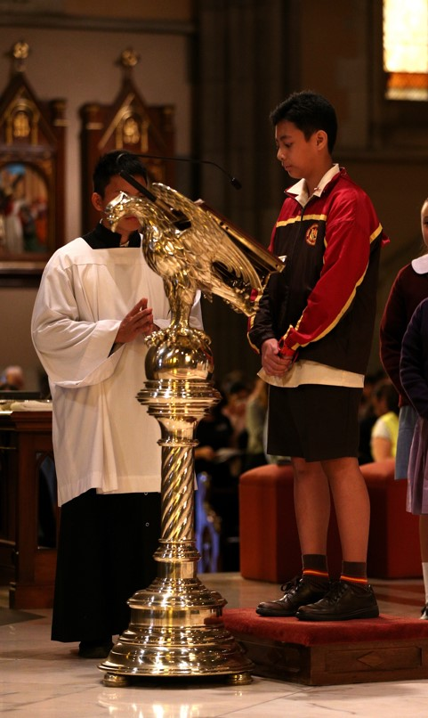

Leadership & Management

Goals & Intended Outcomes
Schools may include the goals and intended outcomes from the Annual Action Plan.

Achievements
In this section schools should describe and/or illustrate their achievements in a manner appropriate to the school community.

EXPENDITURE AND TEACHER PARTICIPATION IN PROFESSIONAL LEARNING
DESCRIPTION OF PL UNDERTAKEN IN 2019
List a range of the Professional Learning activities that staff have undertaken.

NUMBER OF TEACHERS WHO PARTICIPATED IN PL in 2019
AVERAGE EXPENDITURE PER TEACHER FOR PL | $

TEACHER SATISFACTION
Comments regarding the results from the CEMSIS (Catholic Education Melbourne School Improvement Survey) may be included here.

School Community

SIP Goal & Intended Outcomes
To build strong and authentic partnerships with parents and the broader community in the holistic education of our children.
AAP Goals
- To explore ways to enhance connections between the school, parents and parish through traditional means and the use of multimodal tools.
- Work together with the parish to be active participants in their parish plan.
- Create welcome packs for our new arrival students and their families.
Intended outcomes
- That more parents will be engaged in learning.
- That parent voice is enhanced.

Achievements
During the 2019 year, the following achievements and ongoing practices ensured the smooth running of St Gregory’s School in the area of School Community:
- As part of St Gregory the Great’s celebrations of the school Jubilee anniversary the following events were held :
- Commissioning Mass with the Parish and attendance Catholic Education Melbourne representatives, local dignitaries, parishioners and school community members
- A cocktail party for parents and staff members
- The celebration of St Gregory the Great’s Feast Day with the attendance of the Sports organisation who conducted fun activities for all students in multi-aged groups. This was followed by a BBQ provided by the Parents’ Association
- A School Fete
- Students participated in colouring competitions to acknowledge the Chinese New Year. Our students were amongst the winners and attended The Manningham Rejoice Competition Ceremony
- A Mother’s Day Breakfast was held with the guest speaker - Georgina Manning (Director of Wellbeing for Kids, a Counsellor and Psychotherapist). Her presentation was about ‘Self Care’
- Parish and school joined together to provide collaborative support at Working Bees once a term to assist with the maintenance needs of the Parish and school. In addition, the school supported the Parish on Pizza nights that followed Mass and Multicultural Mass and gathering for a shared meal
- Students from local secondary schools which included Genazzano College, Siena College, Whitefriars and Marcellin College completed Work Experience and Community Service placements at St Gregory the Great Catholic Primary School. This enabled secondary students to gain experience in working with staff and students in an educational environment. The school also benefited greatly from the contributions of the varied work that students undertook during their placement
- St Gregory the Great became a site for secondary schools to advertise their forthcoming Open Days and such events as drama performances
- The Principal from secondary feeder schools along with College Registrar and past students from St Gregory the Great Catholic School presented information about their schools to current Year 4, 5, 6 students about their schools and transition to secondary education
- Meetings with coordinators from Secondary schools and St Gregory the Great staff were undertaken to assist students with their transition to secondary education
- Marcellin College Staff and VCAL students were actively involved in supporting the creation of the Belonging Garden and assisted our students through a Buddy program with the planting of shrubs and contributing to the Junior STEM Project
- Parents have actively been involved, encouraged and provided with forums to participate in decision-making processes as representatives on various committees such as the Parish Education Board, Jubilee Committee, Fete Committee, Parents Association, Classroom Representatives, and Graduation Committee
- Annual staff, parent and children CEMSIS surveys were conducted as part gaining information and relevant data to design whole School Improvement and form the 2020 Annual Action Plan
- St Gregory the Great Catholic Primary School Parent community has been generous in its continuous and ongoing support through their roles as volunteers in assisting school events such as sports carnivals, working bees, excursions, gardening groups and library
- Meetings were conducted to provide opportunities for parents to be informed about directions and new initiatives in school programs. These meetings included a Parent Information Meeting at the beginning of the Year, Camp and Human Relations
- Community venues such as Aquanation, Hagenauer’s Reserve, and Currawong Park provided environments for further learning and teaching opportunities related to Sustainability and Health and Physical Education
- Students were provided with incursions (Insects Incursion) to enhance learning and include opportunities that involved expert personnel other than school staff
- The school’s relationship with Grevillea Aged Care Centre has continued. Weekly visits to the school with a small group of aged people and a carer have taken place and Year 4 students benefited from working and learning with our friends from Grevillea on school-related tasks
- Communication remains a high priority to forge relationships with parents and the wider community. Relevant information about school-related events and procedures were communicated to parents through various forums. These have included: online and hardcopy weekly newsletter, flyers advertising forthcoming events, notices related to particular year level activities, Skoolbag apps, Facebook posts and twitter feeds and CareMonkey notices
- Annual Report to the Community, Report from the chairperson of the Parish Education Board was presented at the Annual General Meeting
- Celebrating the diversity of our community was recognised at Chinese New Year celebrations as well as Multicultural Day
- Metro Music, Tennis Hot Shots and Kids Unlimited sessions (Cooking, Karate, and Chess) have provided the opportunity for the students to be involved in additional educational and extracurricular activities within the school day
- Students attended local community events such as the ANZAC Memorial Ceremony and Lead2 Sustain Conference
- Connections with Australian Catholic University and Swinburne Universities provided the opportunity for student teachers to complete their placements and provide staff with the opportunity to mentor prospective graduates
- The school profile is advertised through the school website, Catholic Magazine, Child Manningham, the Leader, billboards and many local kindergartens
- School tours are conducted by Year 6 students to provide the opportunity for prospective families to view the school in action. The tour is followed by a meeting with Michelle Verna, the principal who further provides additional information the parents may require
- As part of 2020 Prep Transition, enrolled Prep students attended regular sessions at the school in the areas around Art, Performing Arts, Technology, and Physical Education. During this time, parents were provided with the opportunity to meet and connect with other families as well as listening to presentations from the Religious Education, Learning and Teaching, Student Wellbeing, and Community Partnerships leaders to inform them about St Gregory the Great school policies, procedures and programs
- Student learning was enhanced by students attending excursions off-site venues with appropriate programs and exhibitions. These included the Halogen Leaders Conference and CERES.
PARENT SATISFACTION
Overall the results from Insight SRC surveys in regard to Parent Satisfaction results are positive in regard particularly to Catholic Identity, School Climate and Student Safety. The scores in relation to the importance the school places on the Catholic ethos, principal and staff approachability, and physical environment are all in the 90% range indicating that the school holds firmly the importance of our Catholic Faith is welcoming and values the importance of nurturing an affirming community.

Future Directions
This section is optional. If not including Future Directions, delete this page and update the table of contents by right clicking on contents, selecting update field and update entire table.
Recommended word length is approximately 400 words.

School Performance Data Summary
The School Performance Summary reports on data in the following areas:
- Proportion of Students Meeting the Minimum Standards
- Average Student Attendance Rate by Year Level
- Teaching Staff Attendance Rate
- Staff Retention Rate
- Teacher Qualifications
- Staff Composition

School data can be found on CEVN under the tab Data Management. Click Annual Report to the School Community 2019. To access the data, scroll down to the heading School Data and click the link Download your SP data. Select the option to download as a word report and copy and paste the data in this section.
Alternatively, you may wish to copy and paste the data into the body of your report and delete this page. E.g. Proportion of Students Meeting the Minimum Standards (NAPLAN) would fit under the heading Student Learning Outcomes and Average Student Attendance Rate by Year Level would fit under the heading Student Attendance. Teaching Staff Attendance Rate, Staff Retention Rate, Teacher Qualifications and Staff Composition would all fit under the section titled Leadership & Management.

NOTE: The School’s financial performance information has been provided to the Australian Charities and Not-for-profits Commission (ACNC) and will be available for the community to access from their website at www.acnc.gov.au

